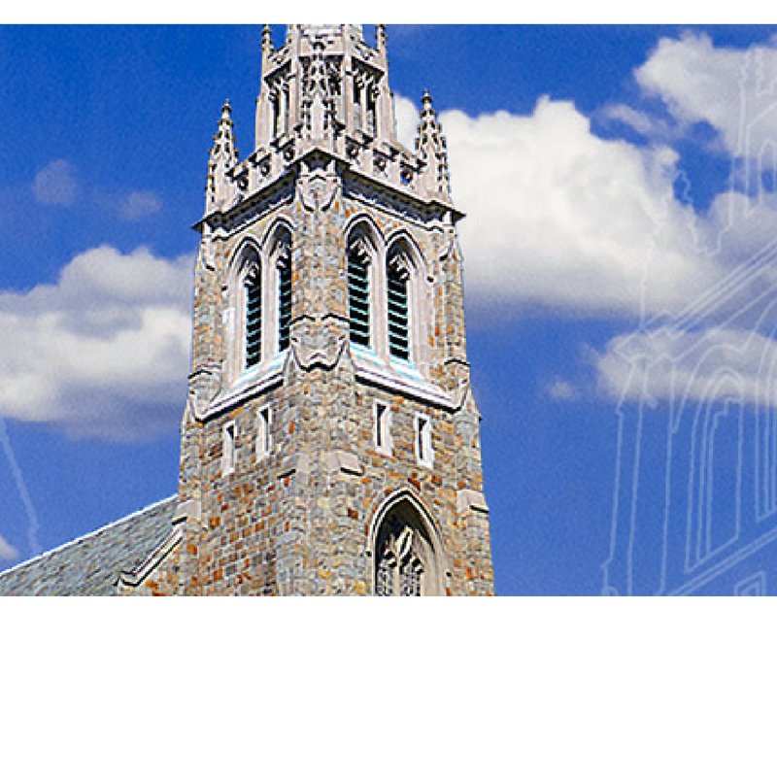The Parish of St. Paul’s on the Green

A Progressive, Diverse Parish of the Episcopal Church Offering

A Radical Welcome to All!

The Sixth Sunday after Pentecost, July 1, 2018

**Welcome!**

**I**t is a joy to have you with us this morning. Please consider returning often! St. Paul’s is a wonderfully diverse community of faith committed to extending God’s radical hospitality to all who enter this sacred space.

**W**e believe in a faith that is based on ancient patterns – worship & music; loving service to the poor, hurt, and lonely; justice and peace work; … *and* a faith that is altogether contemporary – that worship is relevant and informs this day and time.

**W**e believe in the goodness of God’s Creation and in God’s abundant love … so that all who enter this space do so with the freedom to be just as God created you to be … no Outcasts; no Exceptions.

**W**e believe that Christ welcomes all to his table to be nourished in the Holy Eucharist … again no Outcasts; no Exceptions.

**W**e believe that God calls us into community where all may draw closer to a knowledge & relationship with God and each other.

**About Our Worship**

**T**he style of worship here is Anglo-Catholic which draws upon ancient liturgical practices of the Christian Church. You’ll see graceful ritual and colorful vestments, hear chant and exquisite music, and even smell a little incense. We try not to make worship stuffy and, so, you might see acolytes in sandals or sneakers! We hope that you come away refreshed and renewed!

**Holy Communion**

*All are welcome* to receive Holy Eucharist –without regard to age, politics, race, orientation, or identity. *Consecrated grape* juice is available in the glass chalices.

**Kneeling**

The majority of people at St. Paul’s observe the ancient position of standing for prayer. Kneeling cushions are available in the back of the church.

**Children**

*The Chapel of the Angels*, located on the right side of the church, provides a quiet space for *infants and toddlers with their parents.* “Busy bags” are available in the back of the church.

**Children’s Activity**

Children ages 4-8 gather in the rear, center aisle to listen to the Gospel with an adult leader who guides them to the Guild Room for a special worship activity. All return to the church at the time of the Peace. Children are welcome to bring their grown-up’s if they desire.

**Restrooms**

Through double doors on left aisle, downstairs, and in the Warner Center.

**Phones**

Please turn them off.

**This Week**

**Sunday, July 1**

9:00am Solemn Eucharist

with Children’s Worship

10:10 am Coffee Hour, ph

10:10 am Young Children Breakfast, chh*

11:00am Solemn Eucharist

with Children’s Worship

12:10 pm Coffee Hour, ph

12:30 pm ARTWorks Artist Talk, chh*

9:00 pm Compline

**Monday, July 2**

10:00 am Staff Meeting

**Tuesday, July 3**

Office Closed

12:00 pm Prayer Shawl Ministry, gr

**Wednesday, July 4**

Independence day, Office Closed

**Thursday, July 5**

6:00 pm Celtic Eucharist

6:30 pm Gender and the Bible, gr*

**Friday, July 6**

11:00 am Farmers’ Market*

**Sunday, July 8**

9:00am Solemn Eucharist

with Children’s Worship

10:10 am Coffee Hour, ph

11:00am Solemn Eucharist

with Children’s Worship

12:10 pm Coffee Hour, ph

9:00 pm Compline

CHH – Chittim-Howell House; GR – Guild Room;

LC – Lady Chapel; PH – Parish Hall;

WC – Warner Center; SHR – St. Hilda Room

* see inside for more details

****Music Notes**

In Our Prayers

*Please consider keeping these lists and names in your prayers this week.*

**The Episcopal Church in CT**

The 79th General Convention of The Episcopal Church, meeting July 5 – 13 in Austin, TX

**For Healing:**

Alan Anna Mae Anthony

Audrey Barbara Betty

Betsy Bill Bobby

Brenda Caitlyn Carmine Cornelia Dan Deneb

Denise Diana Dottie

Dusty Erik Estela

Eva Gay George John Jon Kenneth

Laura Laura Jean Linda

Lynn Margaret Marissa

Mary Michael Paul

Peter Rhionah Robbo

Sara Sharon Sidney

Steve Susan

Mary Catherine

**For Birthdays:**

John Siguenza (7/02)

Quinn Thornburg (7/06)

Denise Cogliandro (7/07)

**For Anniversaries:**

Rob & Alex Marino (7/01)

Carey & Peter Hahn (7/02)

Jim Labaugh & John Tirone (7/02)

**For Those Who have Died:**

Olger Wernqvist

**Pastoral Care**

If you or a family member is seriously ill or in the hospital, our clergy and Pastoral Care Team are available to support you. Please contact Father Peter Thompson by phone at (571)-643-1377 or email him at: *thompson@stpaulsnorwalk.org*.

During the Summer, all are welcome to take part in the Summer Choir. Even if you have never sung outside of your shower, this is a wonderful opportunity to “try on” the choir. You do not even need to be fitted for vestments – just wear your regular Sunday wardrobe! Each Sunday morning during the summer, meet in the Choir Room located in the Warner Center across from the church at 10 AM to make new friends, learn some simple, satisfying music, and be a part of the Summer Choir--it's low pressure, and a lot of fun.

**Person2Person –Pantry**

This week’s pantry collection is ***Individual Packets of Oatmeal***

*As always, paper and plastic bags are also most welcome.*

*Thank you for your generous support!*

**Hosting Coffee Hour**

*All of us share in the hospitality provided to ourselves and our guests. Each household is asked to offer refreshments twice each quarter. You will receive a request and reminder from the office.*

*Thank you to all who help make coffee hour such a plentiful experience.*

**Coffee Hosts for July 8:**

Winsome Thompson, Olga & Lazaro Tovar, Linda & Bob Turner, Andrea Viehe-Noess, Les & Sussie Walkes, Liz Wernqvist, Kristen Whalen, Barbara Wilcox, Estela Williams, Sara Bennett Wolfe, Bob Davie, Rose Womelsdorf, Jose Padilla & Russ Buckley, Jeanie Loeb, Lodrick Barton, Ed Basile & Catherine Smith, Don Bello, Sandy Bria.

Altar Flowers and Presence Lamp

*Altar flowers may be given in memory of or to honor a particular person or in thanksgiving for God’s gifts. Suggested donation is $80 for both vases. The Presence Lamp is the candle that burns continuously before the reserved sacrament in the Lady Chapel. Suggested donation is $10 per week. Sign up in the Parish Hall or contact the parish office to reserve your week for either.*

The Altar Flowers this morning are given to the Glory of God in loving memory of their daughter and sister, Sarah by Brian, Jane and John Pender and by Michael Cameron in memory of his wife, Agatha.



**Today’s Highlights**

**Calling all Families with Young Children**

* **This morning, Assistant Rector Peter Thompson and Associate for Member Engagement Marsha Dunn invite families with children 8 years old and younger to a special breakfast in the Chittim-Howell House between the morning services.**
* Please plan on joining us at 10:10 am with your ideas about past children’s programming and your thoughts on programming you would like to see at St. Paul’s on the Green.

**Upcoming Events**

**Happy Fourth of July!**

* In observance of Independence Day, the office will be closed this **Tuesday, July 3 and Wednesday, July 4***.*
* *All regular services and activities scheduled for Wednesday will take a break this week, and resume as usual* **Wednesday, July 11.**

**Summer Adult Forum – Gender & the Bible**

* The special summer series will continue **Thursday, July 5 at 6:30 pm** following the Celtic Eucharist. All are welcome to join this thought provoking and enlightening discussion of the Bible from a feminist perspective through the lens of Phyllis Trible's Texts of Terror: Literary-Feminist Readings of Biblical Narratives.
* This week we will consider **Genesis 16:1-16, 21:9-21** and Hagar, the mother of Abraham's first child

**The Farmer’s Market returns this week**

* **The long-awaited return of the Farmer’s Market happens this week!**
* This year, the farmer will be on campus on **Fridays from 10:30 am – 2:00 pm,** be sure to stop by this Friday to take advantage of the wonderful selection of fresh fruits and vegetables.

**St. Paul’s Summer Socials**

* Our first Summer Social event was a wonderful opportunity to gather together, get to know each other a little better, and enjoy a fabulous play.
* For our next gathering, we are planning a Parish Picnic at Shady Beach Sunday, on **Sunday July 15.**
* This will be a fun filled event for all ages. Sign up in the Parish Hall today, or contact Marsha Dunn in the Parish Office at 203-847-2806 or [*admin@stpaulsnorwalk.org*](mailto:admin@stpaulsnorwalk.org)

**St. Paul’s at Laundry Love**

* Laundry Love is a national movement to bring hope to those struggling financially by assisting them with their laundry, so they have the option to redirect funds toward necessities like food, medical, gas or transportation costs, school supplies and other basic, everyday needs.
* 4 churches in the Southwest Region of the diocese have come together with Open Doors shelter and Triangle Community Center in Norwalk to help spread the mission of Laundry Love each month.
* The group meets once a month, and we would like to fill the volunteer rosters with folks from St. Paul’s in August. There are 2 hour shifts available from 3:00 pm to 9:00 pm on **Wednesday, August 1.**
* Please contact Marsha Dunn in the parish office for more information and to pick your time slot.



**S*eabury Academy of Music and the Arts - a 501(c)(3) corporation resident at St. Paul’s dedicated to promoting music and the arts within St. Paul’s and the wider Norwalk community.***

* **ARTWorks Gallery** The *Fairfield County Plein Air Painters* show is now on display the ARTWorks Gallery in the Chittim-Howell House. The artists will be in the gallery at 12:30 pm today to present a special talk about the current exhibit. Come see this beautiful display and hear firsthand the stories behind the art.

**The Parish of St. Paul’s on the Green**

60 East Avenue, Norwalk, CT 06851

Chittim-Howell House

Monday – Friday: 9:00am – 5:00pm

Phone 203‑847‑2806, Fax 203‑847‑5818

*www.stpaulsnorwalk.org*

[*info@stpaulsnorwalk.org*](mailto:info@stpaulsnorwalk.org)

**Weekday Worship**

**Wednesday** 11:30am – Holy Eucharist (Year-round)

**Thursday** 6:00pm – Celtic Eucharist (Sept- June)

**Clergy staff**

**The Reverend Nicholas G. Lang**

Rector, *rector@stpaulsnorwalk.org*

**The Reverend Peter D. Thompson**

Assistant Rector*, thompson@stpaulsnorwalk.org*

**Associate clergy**

**The Reverend Louise Kalemkerian**

**The Reverend Holley B. Slauson**

**Parish Officers**

Wardens: **Bob Giolitto, Louise Truax**

Treasurer: **Paul Hunter** Clerk: **James McNutt**

**Vestry Members:**

**George Anderson, Anthony Crisci, Sean Fulton, Ginny Green, Jennifer Hudson, Chris Spiegelman, Wally Frey, Diane Jellerette, Donna Lewis,**

**Anne Watkins**

**Parish staff**

Director of Music: **Jacob Street**

*street@stpaulsnorwalk.org*

Organ Scholar: **Diana Chou**

Associate for Member Engagement

And Parish Administration: **Marsha Dunn**

*admin@stpaulsnorwalk.org*

Worship Coordinator: **Don Sileo**

*sileo@stpaulsnorwalk.org*

Communication Coordinator: **Will Doughty**

*doughty@stpaulsnorwalk.org*

Facilities Manager: **Steve McCay**

[*mccay@stpaulsnorwalk.org*](mailto:mccay@stpaulsnorwalk.org)

Sexton: **Ferbian Salkie**

**9 & 11 am Solemn Eucharist**

Celebrant: (9am) Mother Louise Kalemkerian

(11am) Father Peter Thompson

Preacher: (9 & 11am) Father Peter Thompson

Deacon: (9am) Father Peter Thompson

(11am) Mother Louise Kalemkerian

Subdeacon: (9am) Patsy Rupp (11am) Donna Lewis

Minister of Ceremony

(9am) Kate Adamson

11am) Anthony Crisci

Children’s Worship Activity:

(9 am & 11am) Jake Street

Thurifer: (9am) Susan Murphy (11am) Diane Jellerette

Crucifer: (9am) Zach DeVito (11am) Ron Voges

Servers: (9am) Don Sileo, Michael Ray

(11am) Jeff Koller, Gisella Foster

Chalicer: (9am) Susan Murphy (11am) Diane Jellerette

Sacristans: (9am) Rob Marino (11am) Mary Roman

Lector: (9am) Rosemary Dellinger (11am) Wally Frey

Minister of Healing:

(9am) (E) **Susan Leggitt,** Lynn Ryan, Barbara Mortimer

(P) **Lynden Magnoli,** Lauren Muldowney, Sherrie Beke

(11am) (E) **Jennifer Hudson,** Ellen Turner, Susan Cole

(P1) **Bob Giolitto,** Barbara McCabe, Tom Hickey

(P2) **Wally Frey,** Joe Shafranek, Mary Roman

Ushers: (9am) Felix Gomez**, Ed Moran**

(11AM) Jim Schilling, **Serafino Carri**

Minister of Welcome:

(9am) Bill Murphy, Susan Leggitt

(11am) Bob Giolitto, Susan Cole

Altar Bread: Nicole DiBella

Altar Flowers: Heather Autore

Person to Person Food Delivery: Jo-Anne Schultz

Counters: Liz Wernqvist, Kate Adamson

Coffee Hour: Donna Lewis, Gladys Lopez, Dorothy Mason. Lauren & Bryan McBeth, Barbara McCabe, Rick & Jan Muldowney, Bill & Susan Murphy, Michael Mushak & David Westmoreland, Richard & Carmen Nash, Fran O'Connor, Janet Rapp, Helen & Sam Rasmussen, Jen & David Scarozza, Joseph Silvers, Jackie Stephens, Charlene Taylor, Lisa Thomas

Compline: Don Sileo, Rosemary Dellinger

**Thank you to all who served and worshiped with us today.**