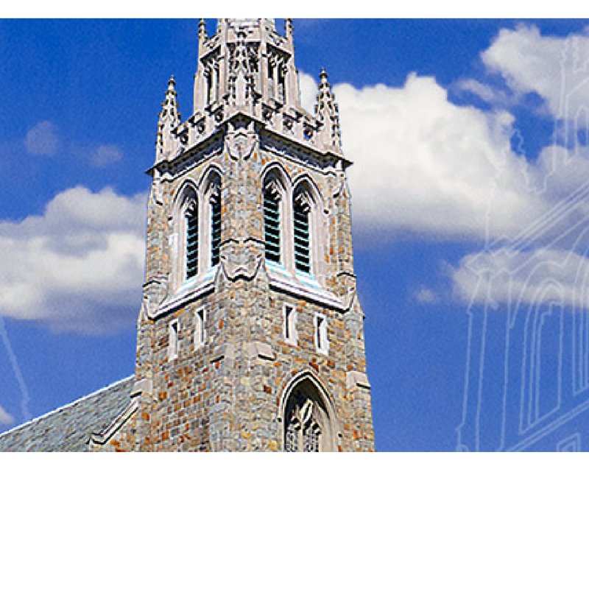The Parish of St. Paul’s on the Green

A Progressive, Diverse Parish of the Episcopal Church Offering

A Radical Welcome to All!

The Nineteenth Sunday after Pentecost, October 15, 2017

**Welcome!**

**I**t is a joy to have you with us this morning. Please consider returning often! St. Paul’s is a wonderfully diverse community of faith committed to extending God’s radical hospitality to all who enter this sacred space.

**W**e believe in a faith that is based on ancient patterns – worship & music; loving service to the poor, hurt, and lonely; justice and peace work; … *and* a faith that is altogether contemporary – that worship is relevant and informs this day and time.

**W**e believe in the goodness of God’s Creation and in God’s abundant love … so that all who enter this space do so with the freedom to be just as God created you to be … no Outcasts; no Exceptions.

**W**e believe that Christ welcomes all to his table to be nourished in the Holy Eucharist … again no Outcasts; no Exceptions.

**W**e believe that God calls us into community where all may draw closer to a knowledge & relationship with God and each other.

**About Our Worship**

**T**he style of worship here is Anglo-Catholic which draws upon ancient liturgical practices of the Christian Church. You’ll see graceful ritual and colorful vestments, hear chant and exquisite music, and even smell a little incense. We try not to make worship stuffy and, so, you might see acolytes in sandals or sneakers! We hope that you come away refreshed and renewed!

**Holy Communion**

*All are welcome* to receive Holy Eucharist –without regard to age, politics, race, orientation, or identity. *Consecrated grape* juice is available in the glass chalices.

**Kneeling**

The majority of people at St. Paul’s observe the ancient position of standing for prayer. Kneeling cushions are available in the back of the church.

**Children**

*Children up to 3 years of age* are welcome in the Nursery, which is staffed from 8:45am to 12:15pm.

*The Chapel of the Angels*, located on the right side of the church, provides a quiet space for infants and toddlers with their parents. “Busy bags” are available in the back of the church.

**Children’s Activity**

Children ages 4-8 gather in the rear, center aisle to listen to the Gospel with an adult leader who guides them to the Guild Room for a special worship activity. All return to the church at the time of the Peace.

**Restrooms**

Through double doors on left aisle, downstairs, and in the Warner Center.

**Phones**

Please turn them off.

**This Week**

**Sunday, October 15**

8:45 am Nursery available until 12:15 pm

9:00am Solemn Eucharist

& Children’s Worship

10:10 am Adult Forum, shr*

10:10 am Coffee Hour, ph

11:00am Solemn Eucharist

& Children’s Worship

12:10 pm Coffee Hour, ph

2:00 pm Apple Picking, offsite*

2:00 pm ARTWorks Closing, gr*

9:00 pm Compline

**Monday, October 16**

10:00 am Staff Meeting, gr

**Tuesday, October 17**

7:00 pm Theology Tuesdays, gr

**Wednesday, October 18**

11:30 am Holy Eucharist

7:00 pm Race & Social Justice Group, gr*

**Thursday, October 19**

10:00 am Farmer’s Market

6:00 pm Celtic Eucharist*

**Friday, October 20**

6:00 & 8:30 pm St. Paul’s Cabaret*

**Sunday, October 22**

8:45 am Nursery available until 12:15 pm

9:00am Solemn Eucharist

& Children’s Worship

10:10 am Adult Forum, shr*

10:10 am Coffee Hour, ph

11:00am Solemn Eucharist w/ Confirmation

& Children’s Worship

12:10 pm Coffee Hour, ph

9:00 pm Compline

CHH – Chittim-Howell House; GR – Guild Room;

LC – Lady Chapel; PH – Parish Hall; N – Nursery;

WC – Warner Center; SHR – St. Hilda Room

* see inside for more details

****Music Notes**

In Our Prayers

*Please consider keeping these lists and names in your prayers this week.*

**The Episcopal Church in CT**

All Saint’s, Cornwall; St. James’s, West Hartford; St. John’s, West Hartford; St. Paul’s Mission of the Deaf, West Hartford; Ministries with older adults

**For Healing:**

Alan Anna Mae Anthony Barbara Betsy Bill

Brenda Caitlyn Camilla Cathy Cornelia Deneb Denise Diana Dusty Ellen Ethel Erik

Erin Estela Eva

Gay George Gina

Henry Jack John

Kate Kristina Linda Margaret Michael Michelle

Peter Rhionah Rob

Robbo Sara Sharon

Sidney Steve Susan

Tommy Mary Catherine

**For Birthdays:**

Jack Fibiger (10/16)

KJ Kelly (10/19)

Eugenia Chinsman (10/20)

Gisella Foster (10/20)

Felix Gomez (10/21)

Carleton Slink (10/21)

**For Anniversaries:**

Bill & Sherrie Beke (10/15)

**For Those who have Died:**

Helen Lamp

**Pastoral Care**

If you or a family member is seriously ill or in the hospital, our clergy and Pastoral Care Team are available to support you. Please contact Father Peter Thompson by phone at (571)-643-1377 or email him at: *thompson@stpaulsnorwalk.org.*

This month in church we will hear much of the music of Anglican composer Edward Bairstow, a famously flinty organist who claimed he would sooner "go to the devil" than relocate to America.  His music uses unusual choral textures to evoke a grand style, capturing the sounds of a cathedral in miniature.  Today's "I Sat Down" surrounds its twisting tenor solo with the other voices singing in their lower registers, giving this short masterpiece a mysterious, otherworldly feel.

**Person2Person –Pantry**

This week’s pantry collection is ***100% Fruit Spread***

Person 2 Person is again holding their *‘***Keep Norwalk Warm’ Coat Drive** on November 4th.  Please consider donating new or gently used coats, scarves and gloves. Contact the parish office for details.

*Thank you for your generous support!*

**Hosting Coffee Hour**

*All of us share in the hospitality provided to ourselves and our guests. Each household is asked to offer refreshments twice each quarter. You will receive a request and reminder from the office.*

*Thank you to all who help make coffee hour such a plentiful experience.*

**Hosts for October 22:**

Jill & Paul Frickenhaus, Scotty Galganowicz & Louise Truax, Stephen Gustafson & Brian McGunagle, Jim Hamilton, Norine Harris, John Harris, Tom Hickey & Joe Shafranek, Nancy Hill, Jim & Geri Hollyday, Shannon & Nathaniel Hoover, Marybeth & Todd Jordan, Joseph Kalemkerian, Serge Karpow, Frank Kimball, Erika Kitano, Elia & Ryan Kopreski, Gerald Krom & Gregory Sheehan, Carleen & Rob Walker, Annalisa Ewald, Eric & Leah Robert, Barbara McCabe, Fran O’Conner.

**A Reminder:  Please either bring your food already plated ... or use one of ours in the kitchen … and stay to serve as host, refilling milk, sugar, plates, etc., as needed, and assisting with tidying up afterward.**

Altar Flowers and Presence Lamp

The Altar Flowers this week are given to the Glory of God in memory of Louise Stadler Martin, by the Watkins family.

*Altar flowers may be given in memory of or to honor a particular person or in thanksgiving for God’s gifts. Suggested donation is $80 for both vases. The Presence Lamp is the candle that burns continuously before the reserved sacrament in the Lady Chapel. Suggested donation is $10 per week. Sign up in the Parish Hall or contact the parish office to reserve your week for either.*



**Today’s Highlights**

**Sunday Adult Forum ~ Today at 10:10 am in the St. Hilda Room**

* This morning in the Adult Forum Series: “*God in the Arts: Encountering the Sacred through the Gift of Imagination”,* **A Life of Guitar:** *Annalisa Ewald on the Joys of Making Music*
* In order for the Bishop to be able to meet with the confirmands, **the adult forum scheduled for next week has been canceled.** The Bishop hopes to return at a later date to present this forum.

**Fall Fun! Apple & Pumpkin Picking ~ This Afternoon, 2:00 pm**

* Everyone is invited for a fun fall outing October 15 to Blue Jay Orchards in Bethel. Plan to meet at the orchard at 2pm to pick your own produce, enjoy some cider and world-famous donuts, or go for a wagon ride!
* See Father Peter Thompson for more details or information about car-pooling.

**Don’t Miss this Year’s “Halloween Boulevard” Cabaret!**

* This year’s Cabaret will be held on **this Friday** October 20th with two fabulous performances to be held at 6 & 8:30 pm. There are a few seats left at each show and plans are to sell tickets up until show time.
* ***Don’t risk being turned away at the door of a sold-out show***! Buy your tickets today during coffee hour.

All Souls’ Day Requiem – Thursday, November 2,

* A Requiem Eucharist (Mass for the Departed) will be celebrated Thursday, November 2, at 7:00pm
* You will find a special envelope in today’s leaflet. Please use it to submit the names of the departed you would like remembered that evening.
* All envelopes with names need to be turned in by Sunday, October 29th for inclusion in the service.

**Upcoming Events**

**Theology Tuesday Series Continues This Fall**

* The Theology Tuesday Series this fall begin with a look at the book *Being Christian* by Rowan Williams.
* This informative session will conclude this week with the topic “Being Anglican/Episcopalian”. Please see [Father Peter Thompson](mailto:thompson@stpaulsnorwalk.org)  for more information.

**Wednesday Race & Social Justice ~ Special Guest This Wednesday 7:00 pm**

* Discussion of Michelle Alexander’s book *The New Jim Crow,* led the Race & Social Justice Team to look for ways tomake practical contributions to the fight against inequality in the criminal justice system. **Jeff Grant**, the Executive Director of the Bridgeport-based Family Reentry program, will be available Wednesday evening at 7:00 pm to offer his thoughts about how best to make such contributions from his experience running a large prison reentry program in the area.

**Bishop’s Visit to St. Paul’s Next Sunday**

* Next Sunday, **October 22,** Ian Douglas, Bishop Diocesan of The Episcopal Church in Connecticut, will be celebrating and preaching at both morning services.
* Additionally, at the 11:00 am service there will be the rite of Confirmation and Reception.
* Please make plans to be here and support these folks who are making or re-affirming their commitment to Christ.

S*eabury Academy of Music and the Arts - a 501(c)(3) corporation resident at St. Paul’s dedicated to promoting music and the arts within St. Paul’s and the wider Norwalk community, with its own separate finances and no strain on the church budget.*

* ***ARTWorks Gallery ~*** Make plans to attend the closing reception this afternoonat 2 pm in the Seabury Gallery located inside the Chittim-Howell House. This is the final chance to experience the exhibit from Natasha Karpinskaia entitled *Pictures at an Exhibition* ~ inspired by the musical composition of the same name by Modest Mussorgsky. Meet the artist, and enjoy her explanation of the inspiration of her work.

**The Parish of St. Paul’s on the Green**

60 East Avenue, Norwalk, CT 06851

Chittim-Howell House

Monday – Friday: 9:00am – 5:00pm

Phone 203‑847‑2806, Fax 203‑847‑5818

*www.stpaulsnorwalk.org*

[*info@stpaulsnorwalk.org*](mailto:info@stpaulsnorwalk.org)

**Weekday Worship**

**Wednesday** 11:30am – Holy Eucharist (Year-round)

**Thursday** 6:00pm – Celtic Eucharist (Sept- June)

**Clergy staff**

**The Reverend Nicholas G. Lang**

Rector, *rector@stpaulsnorwalk.org*

**The Reverend Peter D. Thompson**

Assistant Rector*, thompson@stpaulsnorwalk.org*

**Associate clergy**

**The Reverend Louise Kalemkerian**

**The Reverend Holley B. Slauson, II**

**Parish Officers**

Wardens: **Bob Giolitto, Louise Truax**

Treasurer: **Paul Hunter** Clerk: **James McNutt**

**Vestry Members:**

**George Anderson, Anthony Crisci, Sean Fulton, Ginny Green, Jennifer Hudson, Chris Spiegelman, Liz Wernqvist**

**Parish staff**

Director of Music: **Jacob Street**

*street@stpaulsnorwalk.org*

Organ Scholar **Diana Chou**

Associate for Member Engagement

And Parish Administration: **Marsha Dunn**

*admin@stpaulsnorwalk.org*

*welcome@stpaulsnorwalk.org*

Associate for Pastoral Care: **Lilian Revel**

*lrevel@pobox.com*

Worship Coordinator: **Don Sileo**

*sileo@stpaulsnorwalk.org*

Facilities Manager: **Steve McCay**

[*mccay@stpaulsnorwalk.org*](mailto:mccay@stpaulsnorwalk.org)

Sexton: **Ferbian Salkie**

September – July

Hours: Wed–Fri: 11am-2pm

Sat: 10am-1pm

Sun: 10-11:00am,

12 noon-1pm

Contact Ginny Green, Gift Buyer, at [giftsonthegreen@stpaulsnorwalk.org](mailto:giftsonthegreen@stpaulsnorwalk.org)



**9am & 11am Solemn Eucharist**

Celebrant: (9am) Father Peter Thompson

(11am) Father Nicholas Lang

Preacher: (9am & 11am) Father Nicholas Lang

Deacon: (9 am) Father Nicholas Lang

(11am) Father Peter Thompson

Subdeacon: (9am) Anne Watkins (11am) Nicole DiBella

Minister of Ceremony

(9am) James McNutt (11am) Gisella Foster

Children’s Worship Activity:

(9am) OPEN

(11am) Carol Burgess

Thurifer: (9am) Susan Murphy (11am) Ed Moran

Crucifer: (9am) Ryan Duff (11am) Don Bello

Servers: (9am) Abby Browning, Donna Lewis

(11am) Logan Arias, Frank Kimball

Chalicer: (9am) Susan Murphy (11am) Ed Moran

Sacristans: (9am) Diane Drozd (11am) Mary Roman

Lector: (9am) Alex Marino

(11am) John Verel

Intercessors:

(9am) Gail Bindley-Taylor, OPEN, Diane Drozd

(11am) Max Cisneros, Joyce Davis, Tom Hickey

Ministers of Healing

(9am) (E) **Susan Leggitt,** John Rivera, Sherrie Beke

(P) **Diane Drozd,** Carol Custus, Lynn Ryan

(11am) (E) **Carol Burgess**, Barbara McCabe, David Garlock

(P1) **Lynden Magnoli,** Joe Shafranek, Lisa Thomas

(P2) **Bob Giolitto,** Carey Dougherty, Wally Frey

Ushers: (9am) Felix Gomez, **Gail Bindley-Taylor**

(11am) Ryan Kopreski, **Robin Montgomery**

Minister of Welcome:

(9am) Rosemary Dellinger, Carol Custus

(11am) Jeff Koller, Elizabeth Montgomery

Altar Bread: Madison Stellfox

Altar Flowers: Madison Stellfox

Person to Person Food Delivery: Mary Verel

Counters: Liz Wernqvist, Paul Hunter

Coffee Hour MacLean & Val Cadman, Thomas & Julie Cofone, Greg Cole & John Hamlin, Robert Colella & Gene Roffers, Annie Collier & Lisa Lake, Kevin Connors & Jim Schilling, Carol & James Custus, Andre Darlowski, Nicole DiBella, Danna DiElsi, Patty DosAnjos, Jim & Carey Dougherty, Johannes Enders, Sam Ferris, Alie Foster, Gisella Foster, Wally Frey

**9:00pm Compline:**

Setup & Lighting/Greeters: Brigid Culhane, Ellen Turner

**Thank you to all who served and worshiped with us today.**